**Analysing the Performance & Efficiency of The Radisson Hotels using Data Visualization Techniques**

**INTRODUCTION:**

**Overview:**

The hotel industry is a broad category of businesses that provide lodging services for travellers and tourists. This can include a wide range of establishments, from luxury resorts to budget-friendly motels, as well as extended stay hotels, boutique hotels, and more. Hotels can be found in nearly every corner of the world, and are often a major component of the tourism and travel industry in a given area.

Radisson owns multiple five-star hotels across India. They have been in the hospitality industry for the past 100 years. Due to strategic moves from other competitors and ineffective decision-making in management, Radisson is losing its market share and revenue in the luxury/business hotels category. As a strategic move, the managing director of Radisson wanted to incorporate Business and Data Intelligence in order to regain their market share and revenue. Our task is to create an analytics dashboard & story to provide them insights to make better business decisions.

**Purpose:**

The business requirements for analysing the performance and efficiency of Radisson Hotels include identifying KPIs, comparing performance across different hotels, identifying patterns and trends over time, identifying affecting factors, creating interactive dashboards and reports, identifying areas for improvement, making data-driven decisions, comparing to industry average and creating forecasting models for future performance. The ultimate goal is to gain insights and improve performance through data visualization techniques.

**PROBLEM DEFINITION & DESIGN THINKING:**

**Empathy Map:**

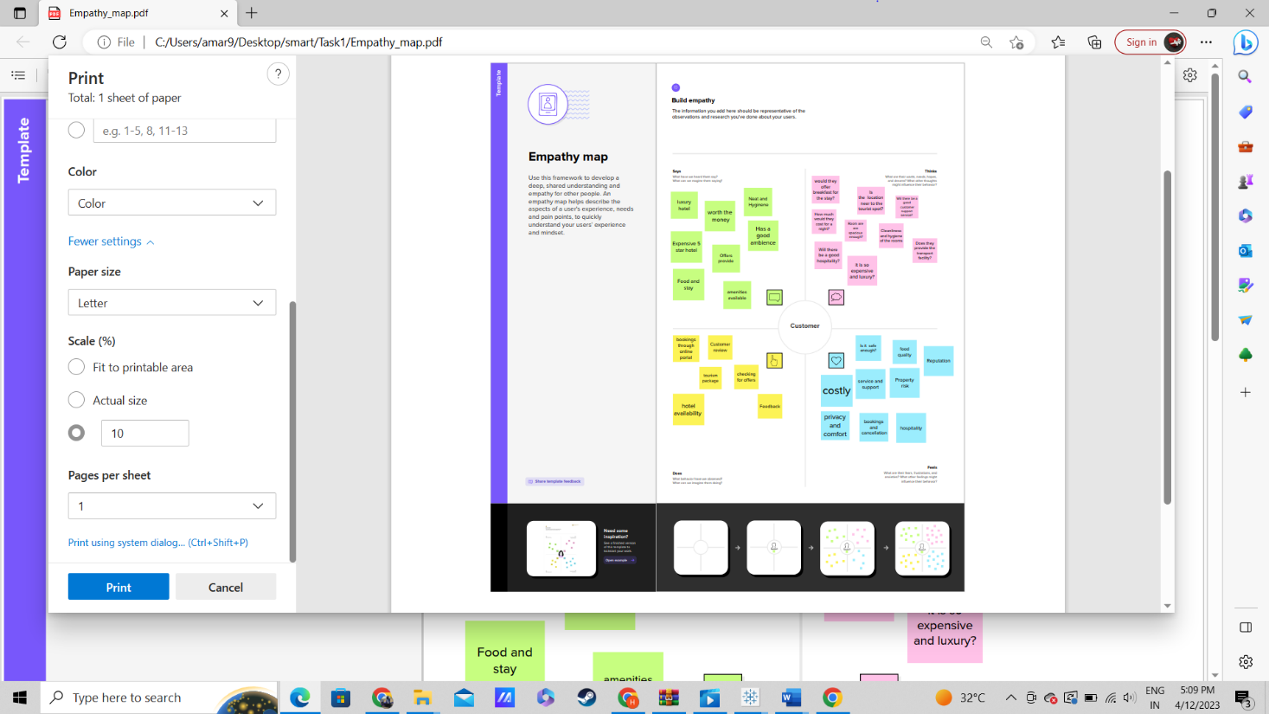

**Ideation & Brainstorming Map:**

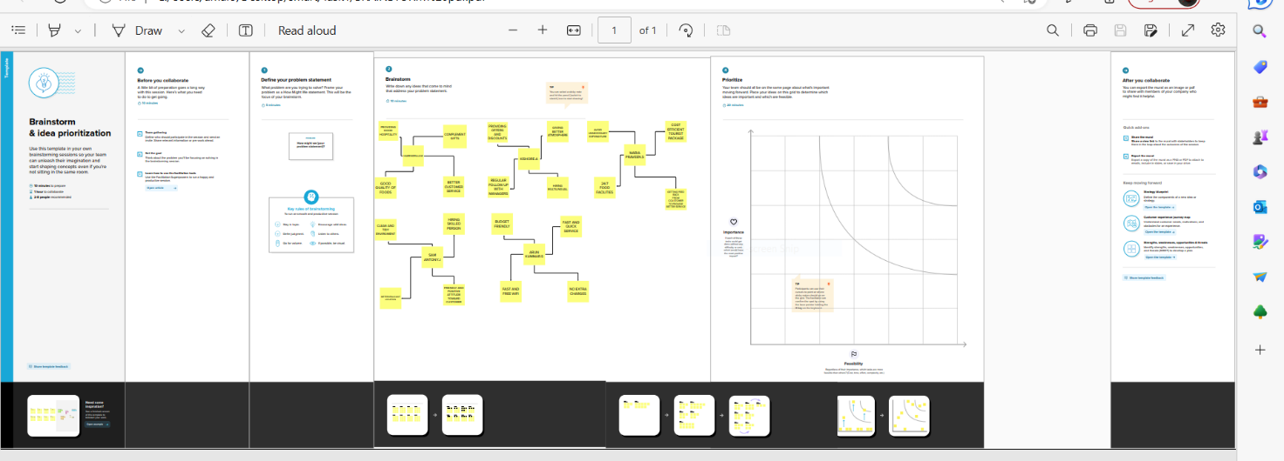

**RESULT:**

**REVENUE SPLIT BY CITY:** 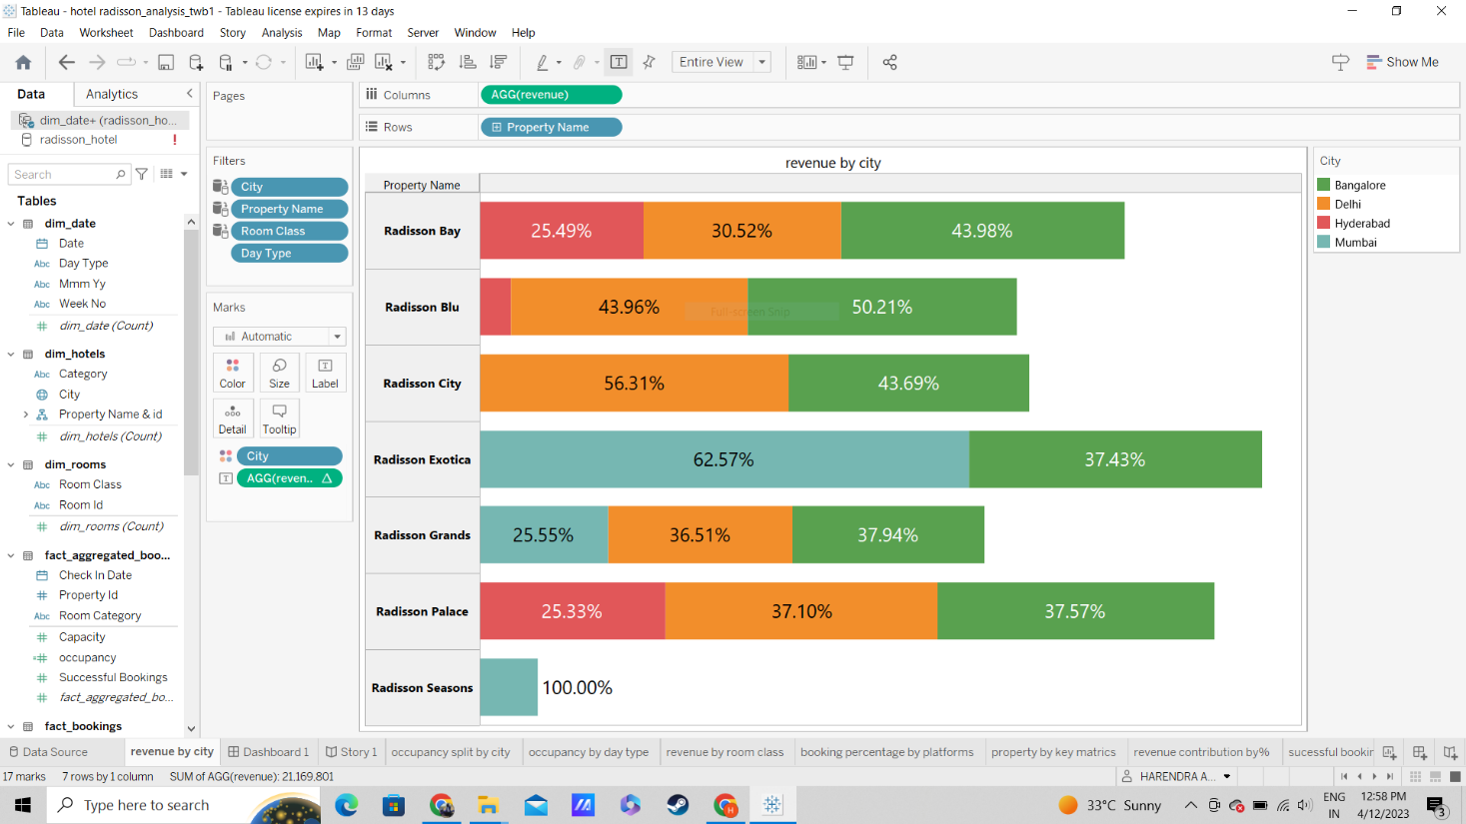

**OCCUPENCY SPLIT BY CITY:**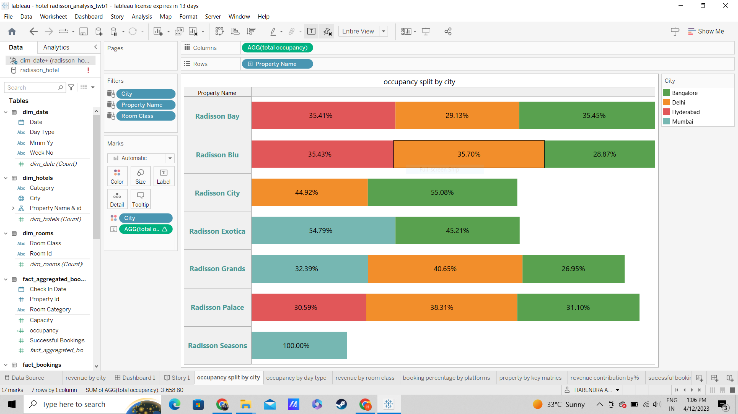

**OCCUPENCY BY DAY TYPE:**

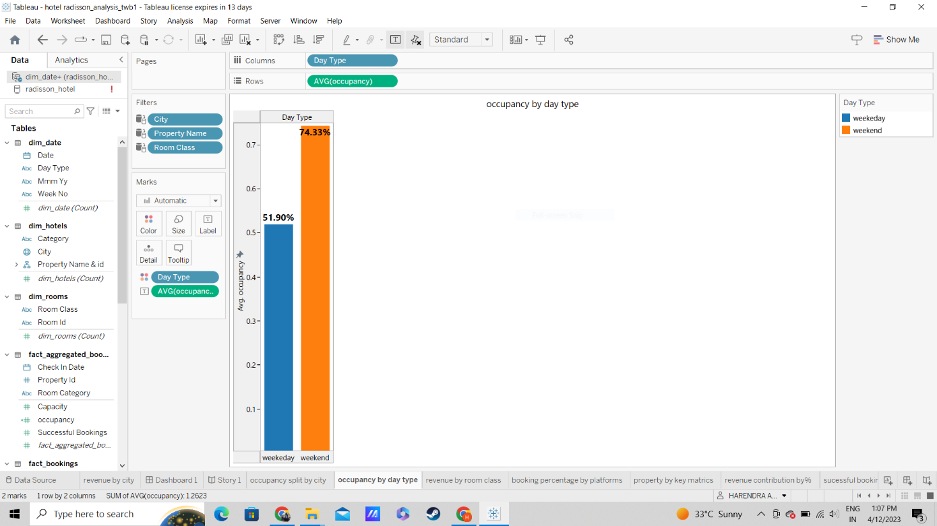

**REVENUE BY ROOM CLASS:**

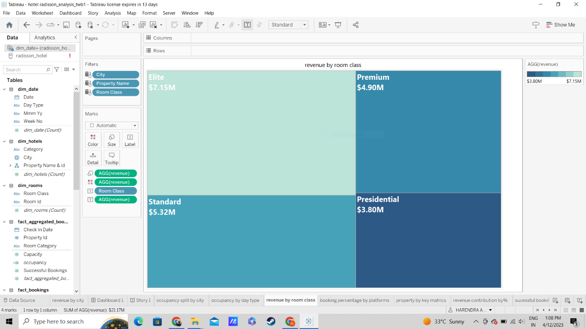

**BOOKING % BY PLTFORMS:**

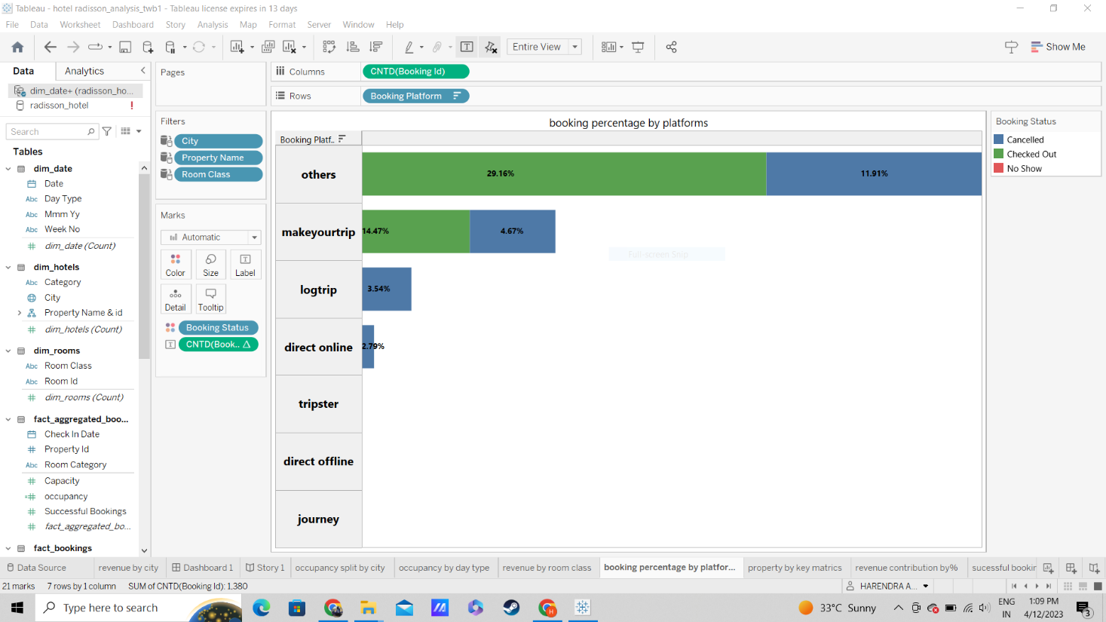

**PROPERTY BY KEY METRICS**

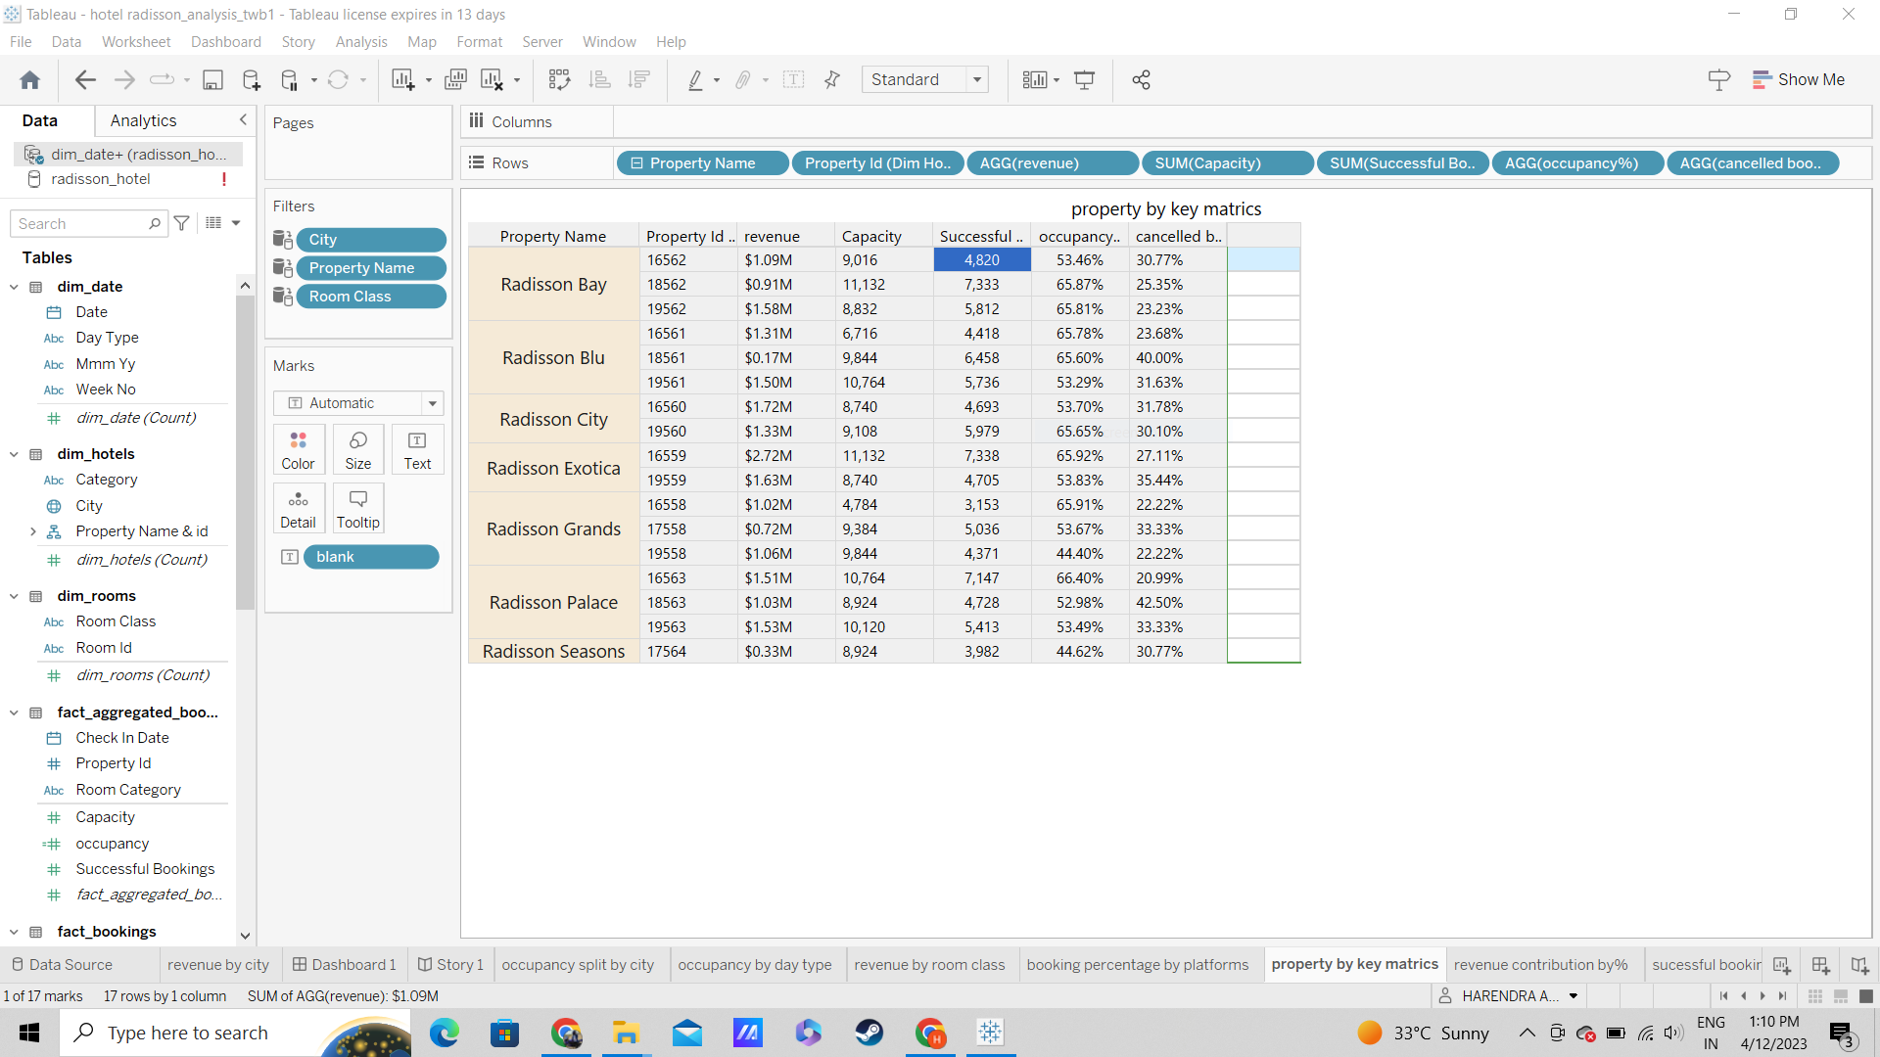

**REVENUE CONTRIBUTION BY % CATEGORY:**

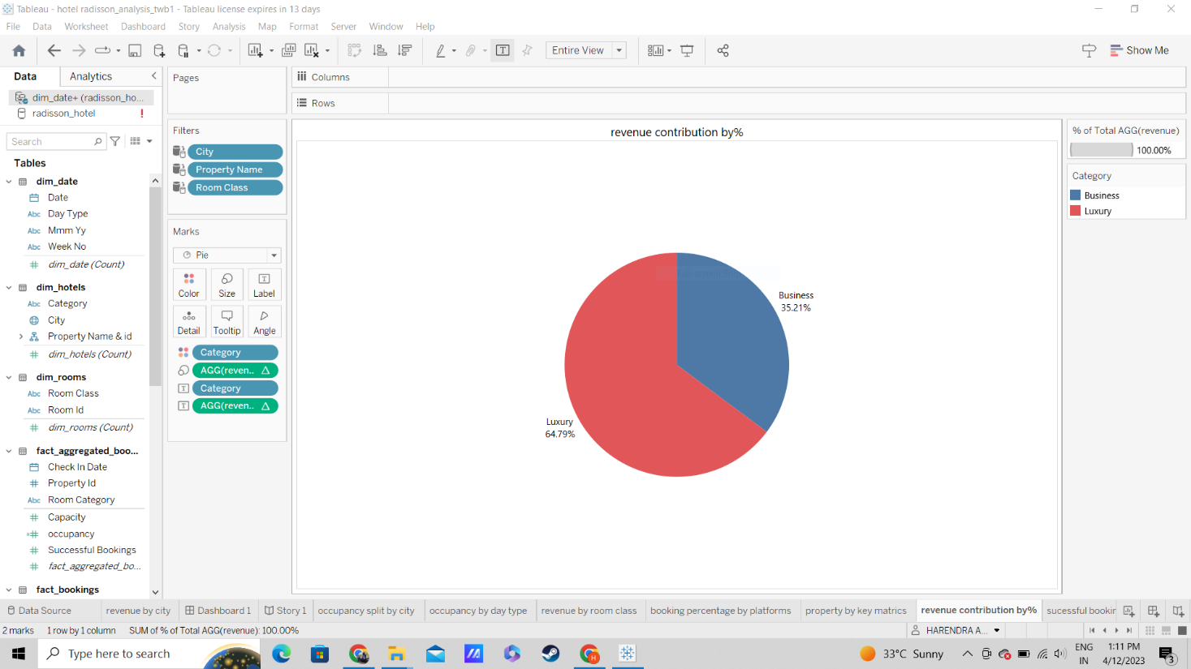

**SUCCESSFUL BOOKINGS BY CITY:**

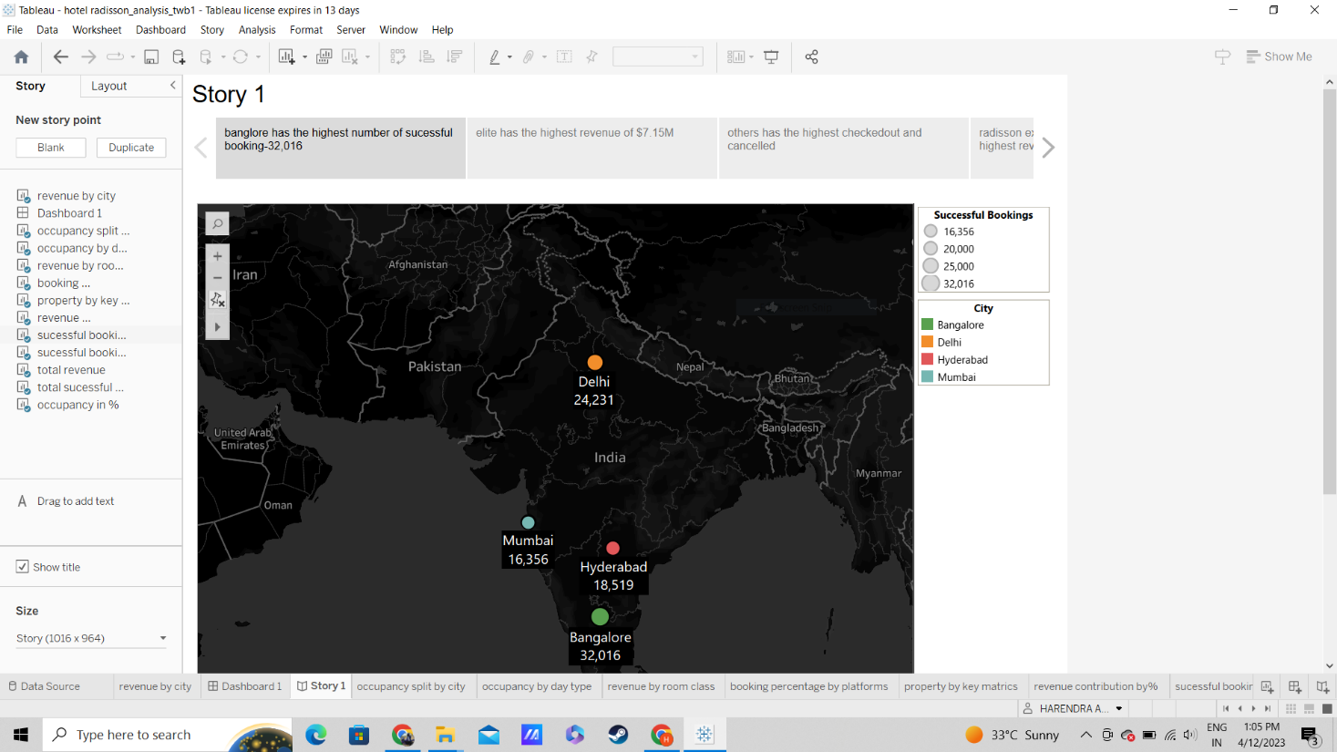

**SUCCESSFUL BOOKING BY DATEWISE:**

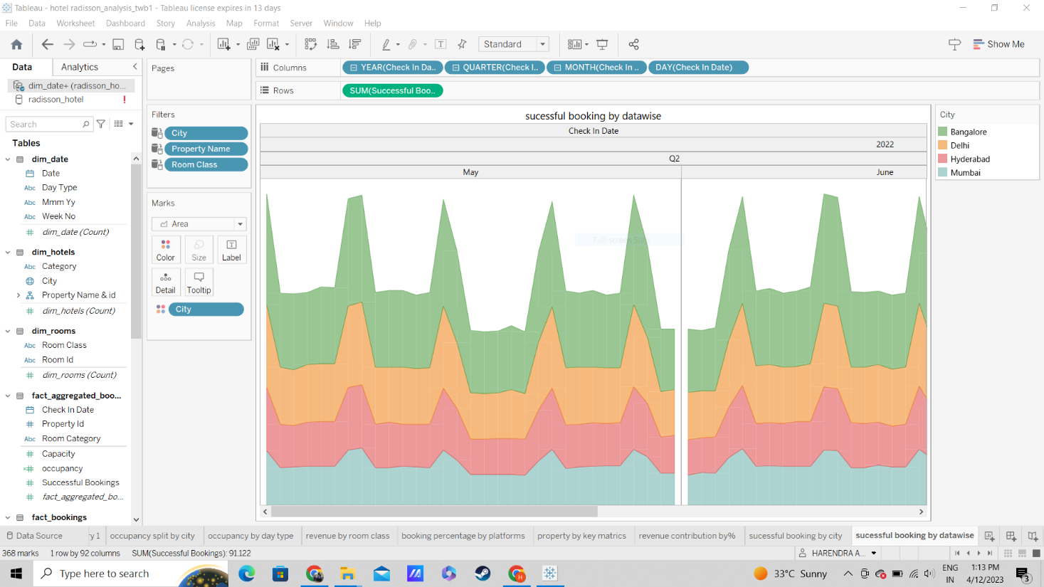

**TOTAL REVENUE ,OCCUPNCY IN % AND SUCCESSFUL BOOKINGS:**

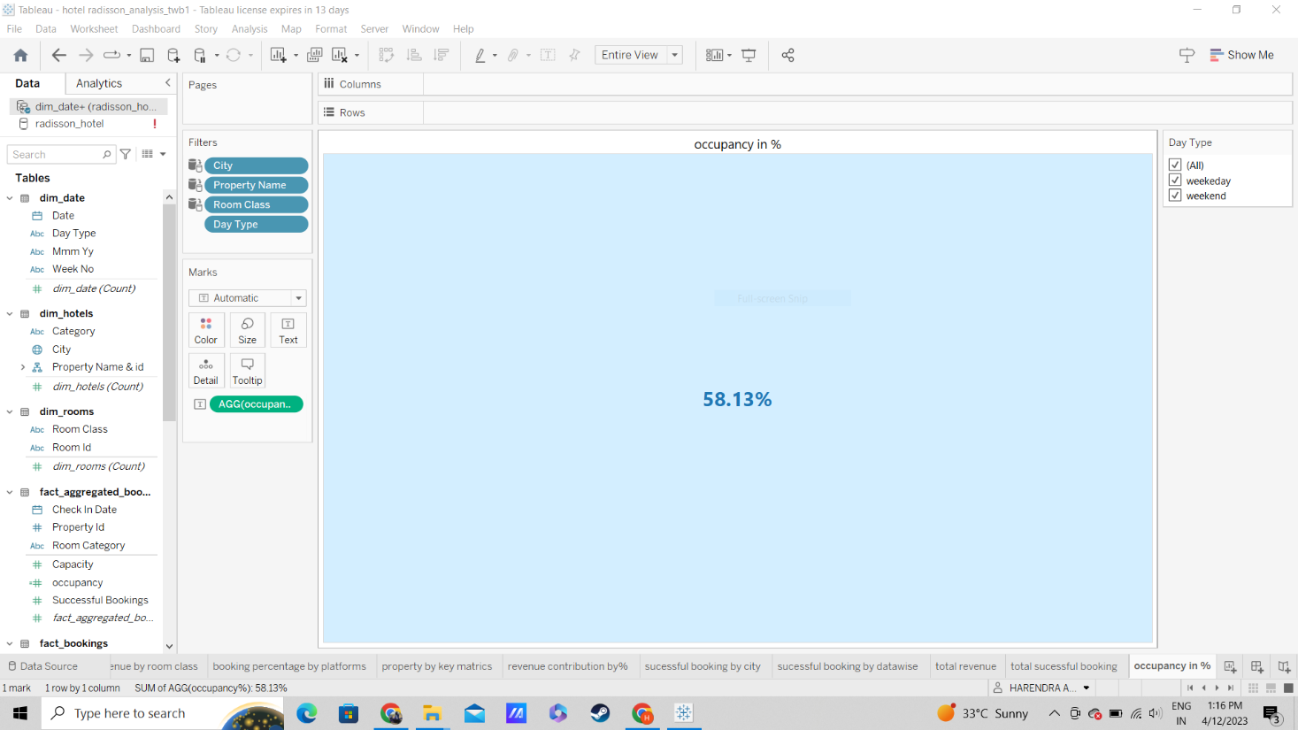

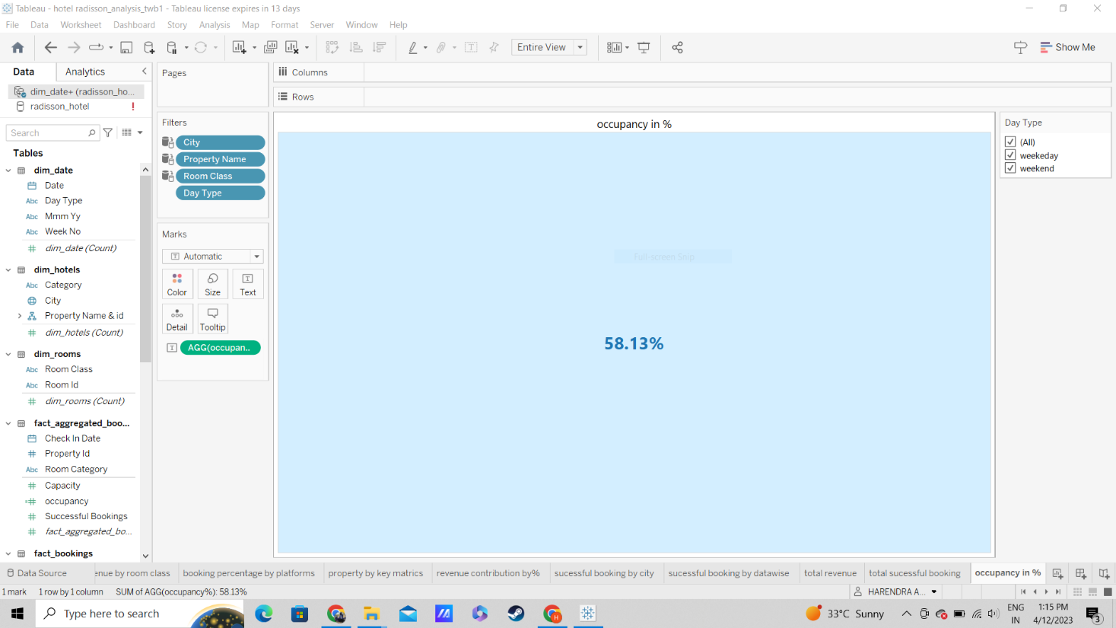

**ADVANTAGES AND DISADVANTAGES:**

**ADVANTAGES:**

1. Clarity: Data visualization techniques can help in presenting complex data in a clear and concise manner. This can help to identify patterns and trends that may not be apparent from the raw data alone.
2. Better decision-making: Visualizations can help to identify key areas where performance and efficiency can be improved. This can enable management to make better decisions and take action to address any issues.
3. Efficiency: Visualizations can help to quickly identify areas that require attention, enabling management to act quickly and efficiently to address any issues.
4. Communication: Visualizations can be used to effectively communicate information to stakeholders, making it easier to share insights and recommendations.
5. Integration: Data visualizations can be integrated with other systems, such as dashboards or reporting tools, to provide real-time insights into performance and efficiency.

**Disadvantages:**

1. Complexity: Some data visualization techniques can be complex and require advanced technical skills. This may require additional training or resources to develop and implement.
2. Bias: Visualizations can be biased if they are designed to show a particular result or outcome. This can lead to incorrect conclusions being drawn from the data.
3. Misinterpretation: Data visualizations can be misinterpreted if they are not designed or presented properly. This can lead to incorrect conclusions being drawn from the data.
4. Lack of context: Visualizations can sometimes lack context, which can make it difficult to understand the underlying factors that are contributing to performance and efficiency.
5. Data quality: Data visualizations are only as good as the underlying data. If the data is incomplete, inaccurate, or outdated, then the visualizations may not provide an accurate picture of performance and efficiency.